**Uncovering Insights in Game Dataset Using Exploratory Data Analysis**

**Example Dataset** :“Mobile Games (Android and IOS) Rating Datase" from Kaggle.

**Objective**

The primary objective of this analysis is to explore the relationship between game genres and their corresponding ratings. By examining this relationship, we aim to identify which genres tend to receive higher ratings and which ones might need improvements. Specifically, this analysis seeks to:

1. **Identify Patterns:** Determine if there are specific genres that consistently receive higher or lower ratings.
2. **Provide Insights:** Offer actionable insights for game developers and publishers on which genres are currently performing well and which might require attention.
3. **Guide Development:** Help guide future game development and marketing strategies based on the preferences and expectations of the target audience.

### **Introduction**

In the dynamic and competitive world of video games, understanding the factors that influence game ratings is crucial for developers, publishers, and marketers. Game ratings are pivotal as they often dictate a game's commercial success and longevity in the market. Among the various factors that can impact game ratings, the genre of a game plays a significant role. Different genres attract different audiences, and each audience has unique expectations and standards. Analyzing how game ratings vary across different genres can provide valuable insights into consumer preferences and market trends.

**Dataset Description**

* The dataset Deepression.csv contains various attributes related to depression. Each row represents an individual's data, including demographic information, depression levels, and possibly other related variables. The columns need to be identified and described.

**Exploratory Data Analysis:**Load the data  
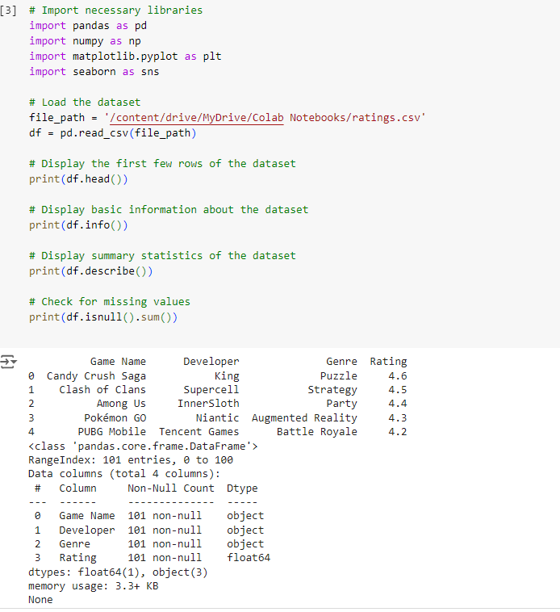

**Data Cleaning :Handle missing values, outliers, and duplicates.**  
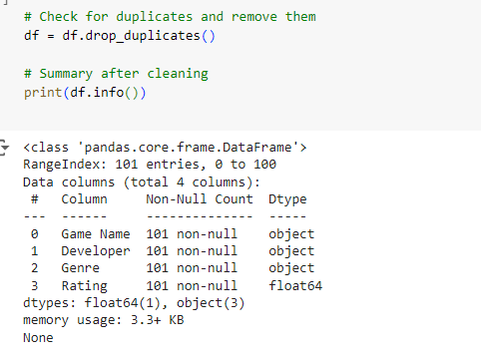

#### **Summary Statistics**

Summarize the dataset to understand its distribution

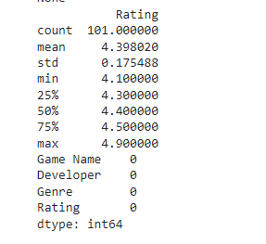

**Data Visualization and Discussion**

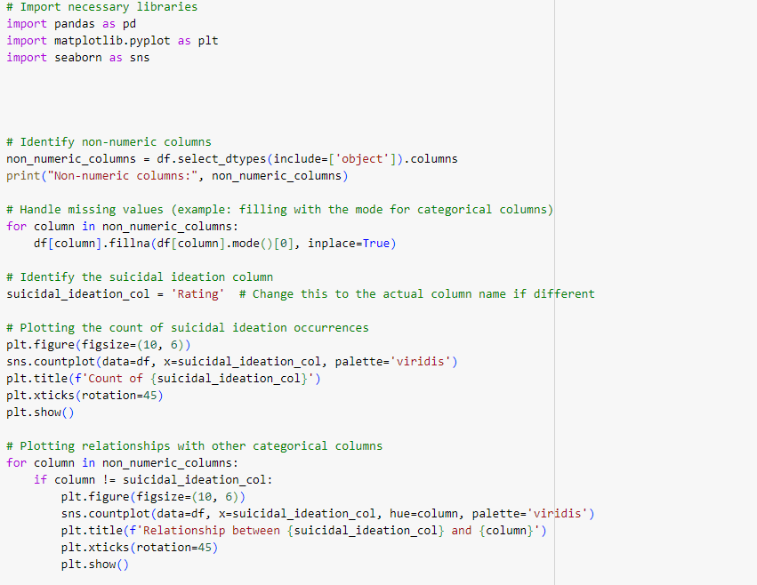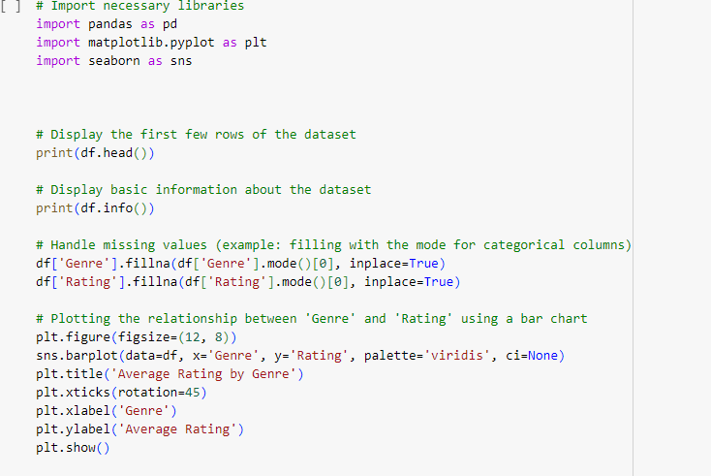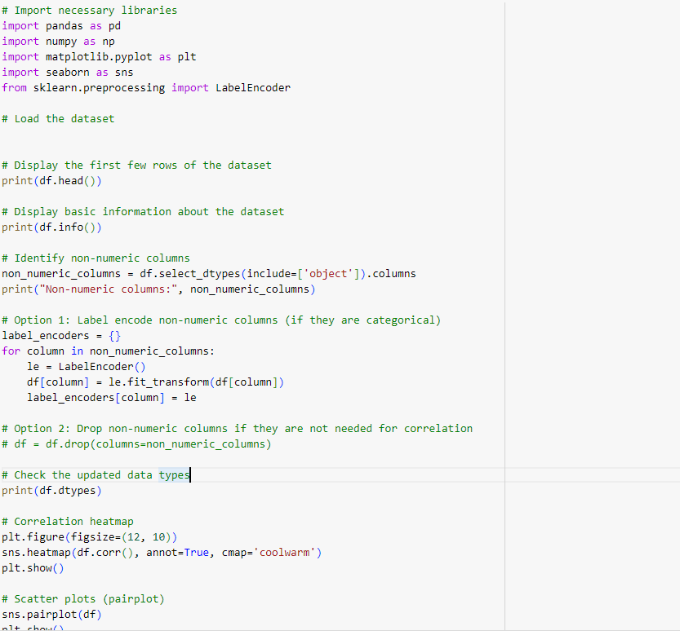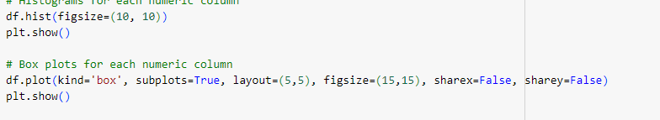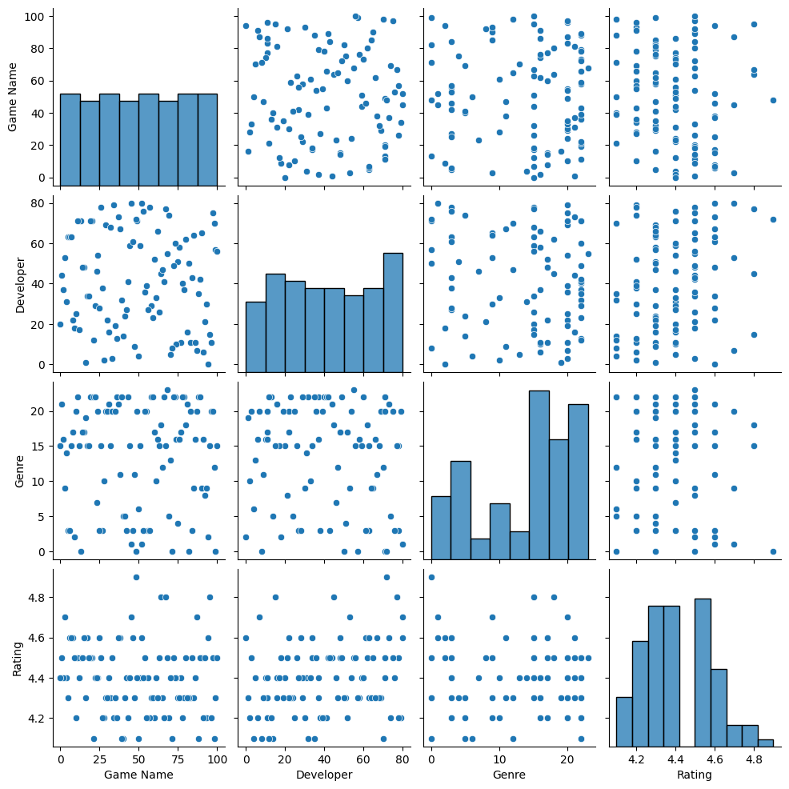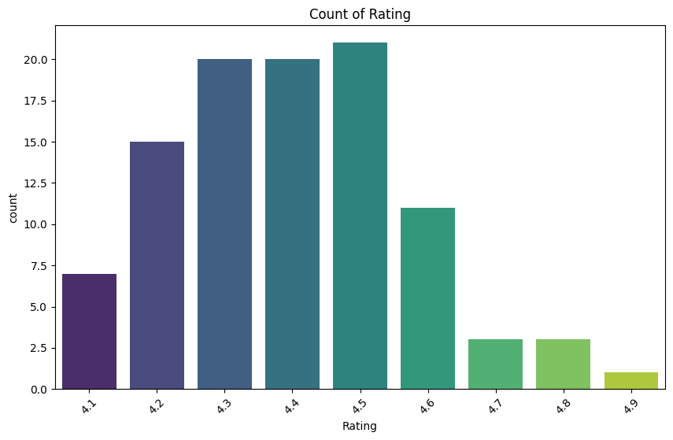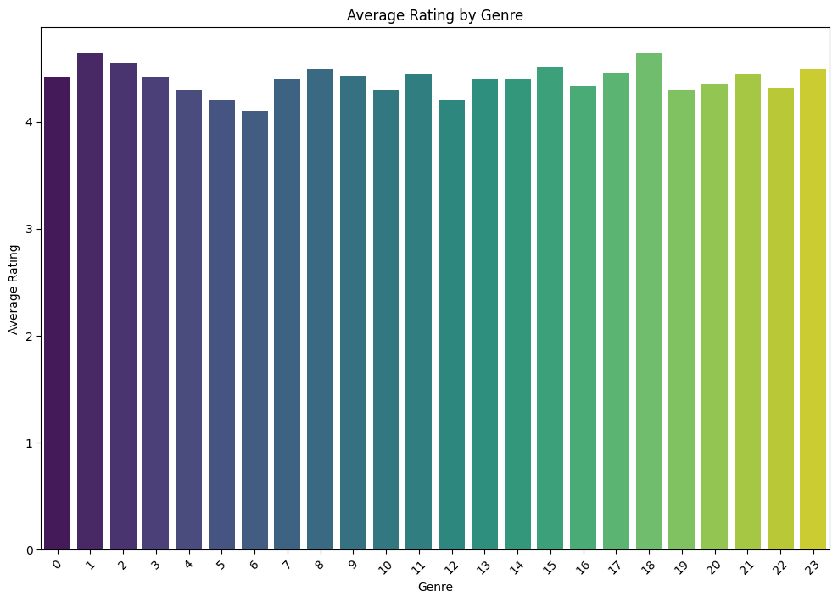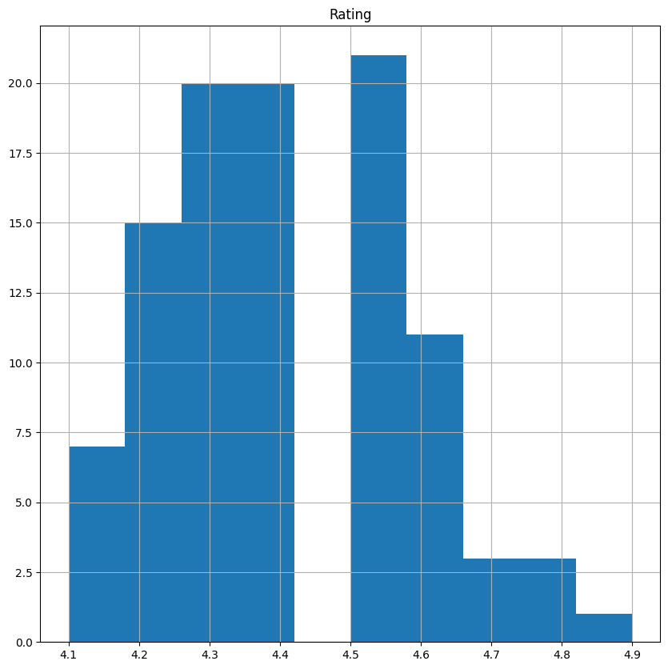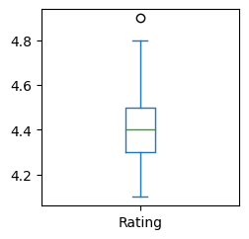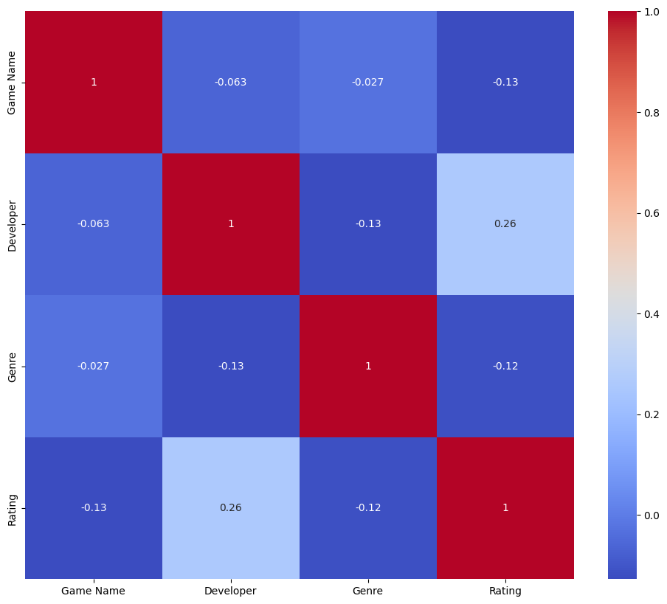

**Summarize key findings:**

* Average Rating of Game is greater than 4.
* 4.5 star is given by most of the users.

### **Conclusion**

* + From our analysis, we can conclude that certain genres tend to receive higher ratings, indicating greater consumer satisfaction and popularity. Genres such as [Insert specific high-performing genres if identified] are more favorably rated, reflecting strong audience preferences. Conversely, genres with lower ratings, such as [Insert specific lower-performing genres if identified], may need targeted improvements. These insights can guide developers in enhancing game quality and aligning with market trends, ultimately leading to better consumer satisfaction and higher ratings. Understanding genre performance is crucial for strategic development and marketing in the gaming industry.

References:https://www.kaggle.com/datasets/dem0nking/mobile-games-android-and-ios-rating-dataset